A “handling” evaluation of the Dentsply Sirona

Class II Solutions system by the PREP Panel

F.J.Trevor Burke, DDS, MSc, MDS, MGDS, FDS (RCS Edin.), FDS RCS (Eng.), FFGDP (UK), FADM^{1,2}
Russell J Crisp, BDS, DGDP²
Peter Sands MSc, BDS, LDS RCS, MFGDP³
1: Primary Dental Care Research Group,
University of Birmingham School of Dentistry
5 Mill Pool Way, Pebble Mill
Birmingham B5 7EG UK, and,
2. The PREP Panel Ltd.
Knutsford, Cheshire, UK
3. General Dental Practitioner, Abingdon, PREP Panel member and part-time Lecturer University of Birmingham
Contacts:
f.j.t.burke@bham.ac.uk 0121 4665476 & 07974 932830 crisp.russell@gmail.com 01565 652211 & 07980 882016

INTRODUCTION

Practice based research
The value of practice-based research has been previously discussed¹, with the arena of general dental practice having been considered the ideal environment in which to carry out evaluations of the handling of dental materials and their clinical effectiveness. In this regard, a wide variety of research projects may be considered to be appropriate to general dental practice, including¹ assessment of materials, devices and techniques, clinical trials of materials, assessment of treatment trends and, patient satisfaction with treatment.
A UK-based group of practice-based researchers is the PREP (Product Research and Evaluation by Practitioners) Panel. This group was established in 1993 with 6 general dental practitioners, and has grown to contain 31 dental practitioners located across the UK, with one in mainland Europe². The group have completed over 70 projects – “handling” evaluations of materials & techniques, and more recently, clinical evaluations (n=8) of restorations placed under general dental practice conditions, with the restorations being followed for up to five years².
Resin composite systems
As patients increasingly move away from amalgam restorations in their posterior teeth³, with the added impetus of the Minamata Agreement by which the use of amalgam has been banned, from 1st July 2018, in children 15 years and younger and pregnant and nursing women, dental practitioners have had to use an alternative material, the most appropriate of which is resin composite. In this regard, practice-based clinical evaluations of this material have indicated positive results⁴⁻⁷. However, in order to obtain such results, along with the resin composite material, a variety of materials and devices must be employed, for example, a dentine-bonding agent, a suitable matrix system and a polishing system. For the first time, to the authors’ knowledge, all of these have been marketed as a single system, the Dentsply Sirona Class II solutions system. It is therefore the aim of this study to evaluate the opinions of a group of practice-based researchers, the PREP Panel, of the components of this system, and the system as a whole.
The Dentsply Sirona products under evaluation therefore are: the dentine bonding system Prime & Bond Active, the Palodent V3 Sectional Matrix System, SDR+ Flow composite, Ceram.X universal composite and the Enhance finishing & polishing system, all manufactured by Dentsply Sirona, Building 3, The Heights, Brooklands, Weybridge, Surrey, KT13 0NY at www.dentsplysirona.com/en-gb)
METHODS
Selection of participants
All 31 members of the practice-based research group, the PREP Panel, were
sent an email communication asking if they would be prepared to be involved
in the “handling” evaluation of a recently-introduced Class II resin composite
system. Of those who agreed to participate, twelve were selected at random.
A questionnaire was designed jointly by the PREP Panel co-ordinators and
the sponsors of the project in order to seek information on the handling of the
various materials and devices which formed the Dentsply Sirona Class II
Solutions system.
Explanatory letters, questionnaires and a package containing a bottle of Prime
& Bond Active, a Palodent V3 Sectional Matrix introductory kit, an SDR Flow+
kit with 4 shades (Universal, A1, A2, and A3), a ceram.X Universal
Introductory kit and compule gun, and an Enhance finishing system complete
kit, were distributed to evaluators in March 2018. The practitioners were
asked to use the materials as indicated and return the questionnaires after 10
weeks. At the request of Dentsply Sirona the evaluation period was shortened
to 7 weeks.

Regarding the evaluators, two were female and their average time since graduation was 28 years, with a range of 13 to 45 years.

The evaluation:
Dentsply Sirona Prime & Bond Active
All the evaluators currently used a dentine/enamel bonding system.
Reasons for the choice of these materials were primarily ease of use & good results. Other reasons were good research behind product, good ‘wettability’, with comments being made, such as “Reliable and effective” (2 similar), “Single dose dispensing”, “Practice owner purchase”, “Historic use & good results” (2 similar), “Single use dispensing pack”.
When the evaluators were asked to rate the ease of use of the current bonding system, the result was as follows:
Difficult to use 1 5 Easy to use
4.8
Ten (83%) evaluators stated that they preferred a bottle presentation,
With 92% (n=11) of the evaluators also stating that they would not be prepared to pay extra for the convenience of single-unit doses.
The evaluators rated the presentation of Prime & Bond Active (Figure 1) as follows:
Poor 1 5 Excellent 4.9
Comment:
“Use a non-plastic handle for micro-brush”
The bottle dispenser was stated to be easy to use by all (100%) of the evaluators. The cleanliness and ease of cleaning the bottle was rated as follows:
Poor 1 5 Excellent
4.3
414 restorations were placed using Prime and Bond Active, comprising 102 Class I, 125 Class II, 62 Class III, 52 Class IV and 73 Class V.
The mode of etching preferred for Prime and Bond Active was stated to be as follows:
Total Etch 5
Self Etch 1
Selective Enamel Etch 8
Eleven (92%) of the evaluators stated that the dispenser worked satisfactorily.
However, two comments were made, namely, “Lid flimsy & didn’t always close fully” (3 similar comments).

Figure 1: Prime & Bond Active
All (100%) of the evaluators stated the resin liquid easily wet the tooth surface and that the bond was easily visible on the tooth surface.
Fifty per cent (n=6) of the evaluators felt the absence of the need to wash off a separate etching liquid with Prime and Bond Active was an advantage and 83% (n=10) of the evaluators stated that the one-component aspect of Prime and Bond Active was an advantage over other systems with more than one bottle.
Four evaluators (33%) stated that the application of Prime and Bond Active was faster than the application of other bonding adhesives they had used, with one evaluator stating it was slower. Seven (58%) stated it was the same as other bonding adhesives and 75% (n=9) of the evaluators stated that they would purchase Prime and Bond Active if available at average price. When they were asked if there were any changes which they considered essential to the acceptability of the material the following comments were made by three (25%) of the evaluators:
“Better container”
“I always use selective etch enamel, even with self-etch systems”
“Strong smell commented on by patients: I and my nurse found it unpleasant” (2 similar)
When the evaluators were asked to rate the ease of use of the Prime and Bond Active, the result was as follows:
Difficult to use 1 5 Easy to use
4.8
Final comments:
“Liked the way it evaporated on drying – much less “gloop” to be removed than Scotchbond Universal in the interproximal areas”
“If subgingival, agitation can cause mucosal irritation and bleeding”
“Prefer Scotchbond bottle, but liked the consistency of Prime & Bond Active”
75% (n=9) of the evaluators stated they would purchase the material if available at an average price.

Dentsply Sirona Palodent V3 Sectional Matrix System
Figure 2: The Palodent V3 sectional matrix system intro kit, containing matrices, wedges, wedge guards, bitine rings, tweezers and ring forceps. 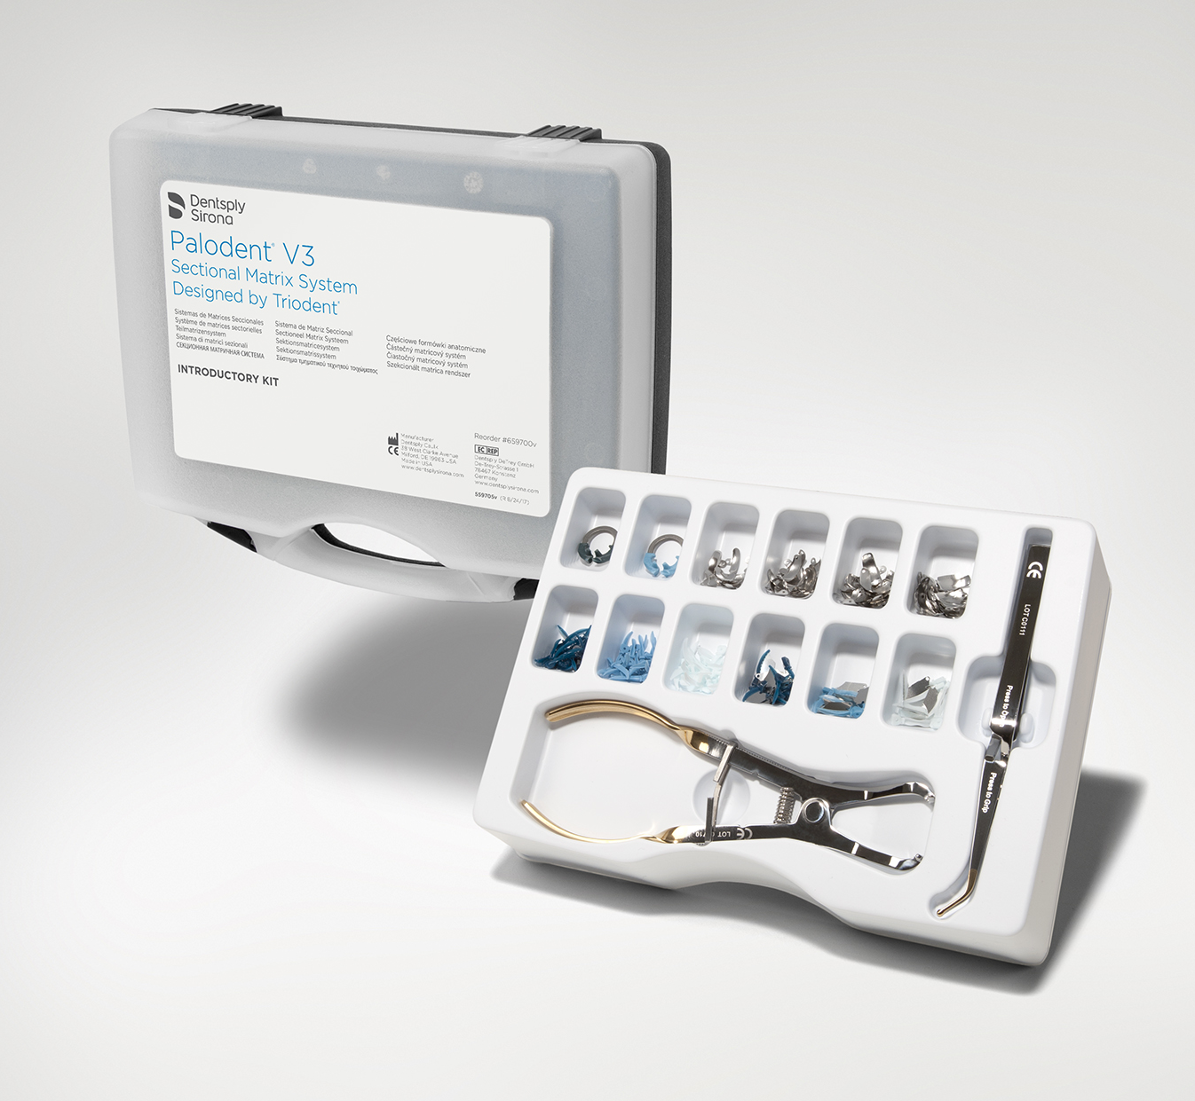
Seven (58%) of the evaluators currently used a sectional matrix system, with five using the V3 prior to the evaluation. The ease of use of the currently used sectional matrix system was rated as follows:
Difficult to use 1 5 Easy to use
4.3
The size of interproximal box for which typically the evaluators used a sectional matrix was as follows:
Narrow interproximal box not extending to the embrasure spaces:6 evaluators
Wider interproximal box extending into the embrasure spaces: 9 evaluators
Very wide interproximal box extending partly to a cusp: 7 evaluators
Cusp replacement: 5 evaluators
The evaluators rated the presentation of V3 Matrix System as follows:
Poor 1 5 Easy to use
4.8
All the evaluators stated the components in the box were neatly laid out and
readily identified, and also that the instructions were adequate.

One hundred and sixty-seven restorations were placed was using the V3 matrix system, comprised of 97 Class II, 47 MOD and 23 cusp replacement. Ten (83%) of the evaluators stated the matrix was easily held and transferred into place and 75% (n=9) of the evaluators stated that the locating hole in the matrix was an advantage over systems without such a feature. The curved shape of the matrix was stated to be advantageous by 92% (n=11) of the evaluators.
The nickel titanium retaining ring of the V3 system was stated by 83% (n=10) of the evaluators to satisfactorily hold the matrix in place, and the same number also stated it was easy to place using the ring forceps. 83% (n=10) of the evaluators found the ring to be advantageous in adapting the matrix to the edges of the box, so reducing the amount of excess composite filling material needing removed.
Comments made included:
“More likely to slip on short crowns or rotated teeth”,
“Well made and easy to place”,
“Two rings in kit, but longer ‘legs’ would be advantageous for deep boxes”, “Larger rings please for large teeth and wider jaws on rings to help hold matrix when there is a broken cusp”
92% (n=11) of the evaluators stated that no patients returned complaining of food packing. If the V3 Matrix system was available at an average price, 83% (n=10) of evaluators would purchase it.
Five evaluators (42%) considered there were changes essential to the acceptability of the system, making comments such as:
“Adopt the Garrison softer ‘cushions’ to allow the ring to conform to the tooth embrasure” (2 similar),
“Clarify which band for which tooth rather than just in mm”, and,
“Provide a deeper band for deep boxes”.
Fifty per cent (n=6) of evaluators felt that the V3 matrix system was easier to use than a circumferential system.
Comments made included:
“Horses for courses, as no one system does everything. V3
is the best sectional matrix system”,
“Haven’t found one yet that is easier but they do produce significantly better contacts”,
“Not sure I’d ever use the very small matrices so don’t include in kit”,
“The hole is excellent for securely holding the matrix & wedges but takes a little getting used as the forceps are counter-intuitive (i.e. usually pressing together usually grips – these are the opposite)”,
“Matrices themselves a little thicker than the ones I am using but this can be advantageous as very thin ones can bend and wrinkle”.
It was also suggested that a ‘tips/tricks’ guide would be useful to help with the
learning curve.
The ease of use of the V3 matrix system was rated as follows:

Difficult to use 1 5 Easy to use
4.2
The five evaluators new to sectional matrices rated the “steepness” of the
learning curve as follows:
Shallow 1 5 Steep
3.7
83% (n=10) of evaluators would recommend the Palodent V3 matrix system to colleagues.

Dentsply Sirona SDR FLOW+
The presentation of the kit was rated by the evaluators as follows:
a) in terms of completeness of the system:
Poor 1 5 Excellent
4.8
b) overall presentation:
Poor 1 5 Excellent
4.4
Comments:
“Came in little bags – not normal, but OK for me”
The evaluators rated the directions for use of SDR Flow+ as follows:
Poor 1 5 Excellent
4.9
92% (n=11) of the evaluators had previously used Bulk Fill materials.
Stated uses included:
“Mainly after root treatment to obturate access cavity”,
“Seals margins & levels floor of cavity. Saves time with deep occlusal cavities”,
“Can place in large increments, therefore saves time” (2 similar),
“Large posterior restorations & core build-ups after endo” (2 similar),
“Speed and simplicity” (2 similar).
Half of the evaluators also used SDR Flow+ for other indications, such as restoration of fractured cusps, base of deep boxes” (3 similar), repairs and Class V restorations, and for sealant restorations”.
The total number of posterior restorations placed using SDR Flow+ was 127,
comprised as follows:
Class I 28
Class II 72
Other Cavity Classes/ Indications 27
The evaluators indicated the following, when asked to complete the table below:
Procedure | Number who would consider using SDR+ Flow for this procedure
Amalgam | 4
Glass Ionomer open sandwich/technique | 2
Glass Ionomer closed sandwich/technique | 2
Bulk fill posterior composite | 5
Layering of universal composite | 7
Flowable as a liner | 11
Flowable as a bulk-fill base | 7

75% (n=9) of the evaluators stated the viscosity of the material was satisfactory.
When the evaluators were asked to tick on the following table whether they found SDR Flow+ to be better, the same or worse (than other similar materials that they have used), the results were as follows:
 | Better | The Same | Worse
Simplicity of procedure (convenience/fewer steps) | 7 | 3 | 1
Internal cavity adaptation | 6 | 4 | 1
Ease of placement | 7 | 3 | 1
Creation of positive contact when used with V3 | 1 | 7 | 1
Time saving | 7 | 4 | 0

92% (n=11) of evaluators stated they were satisfied with SDR Flow+, and
75% (n=9) would purchase the material.

The following attributes of SDR Flow+ were rated by the evaluators as
follows:
a) Simplicity of procedure (convenience/fewer number of steps)
Difficult 1 5 Simple
4.8
b) Internal Cavity Adaptation
Poor 1 5 Excellent

4.8
c) Ease of placement

Difficult 1 5 Easy

4.5
d) Creation of Positive Contact when used with V3
Poor 1 5 Easy 4.3
e) Time saving
None 1 5 Significant 4.3

After having used SDR Flow+, the evaluators’ comments on the concept of bulk filling under resin composite restorations for posterior teeth were as follows:
“Tried a few systems but not liked them but SDR Flow+, now one of my “go to” composites”
“Use with care not to stress the tooth. Great for non-vital teeth prior to crowning”
“Use already – a great technique and I recommend it” (2 similar)
“Great time saver”
“Time saver in Class I’s but in Class II’s it was challenging due to the
slump of the material flowing away from where placed”
“Adapts well & creates good seal”
“Easy to use”
Final comments on SDR Flow+ included:
“Excellent product – best bulk fill I have come across”
“Nice fine tip for application of the material”
“Loved the various shades – I have been waiting for this to happen”
“I found the material easy to use in Class I restorations”
“Not sure about it – flow too fluid and difficult to control in my hands”
“I liked the idea of a bulk fill with good adaptation to the cavity but I do like to place a layer or two of conventional composite for optimal aesthetics. I liked the combination of SDR Flow+ and ceram.X – I presume polymerisation stress issues have been addressed with SDR Flow+”
“I liked the longer nozzle compared with the flowable I have used and it isn’t stringy or pulls back”

Dentsply Sirona ceram X universal resin composite material
Figure 3, the Dentsply Sirona ceram.X Universal resin composite material

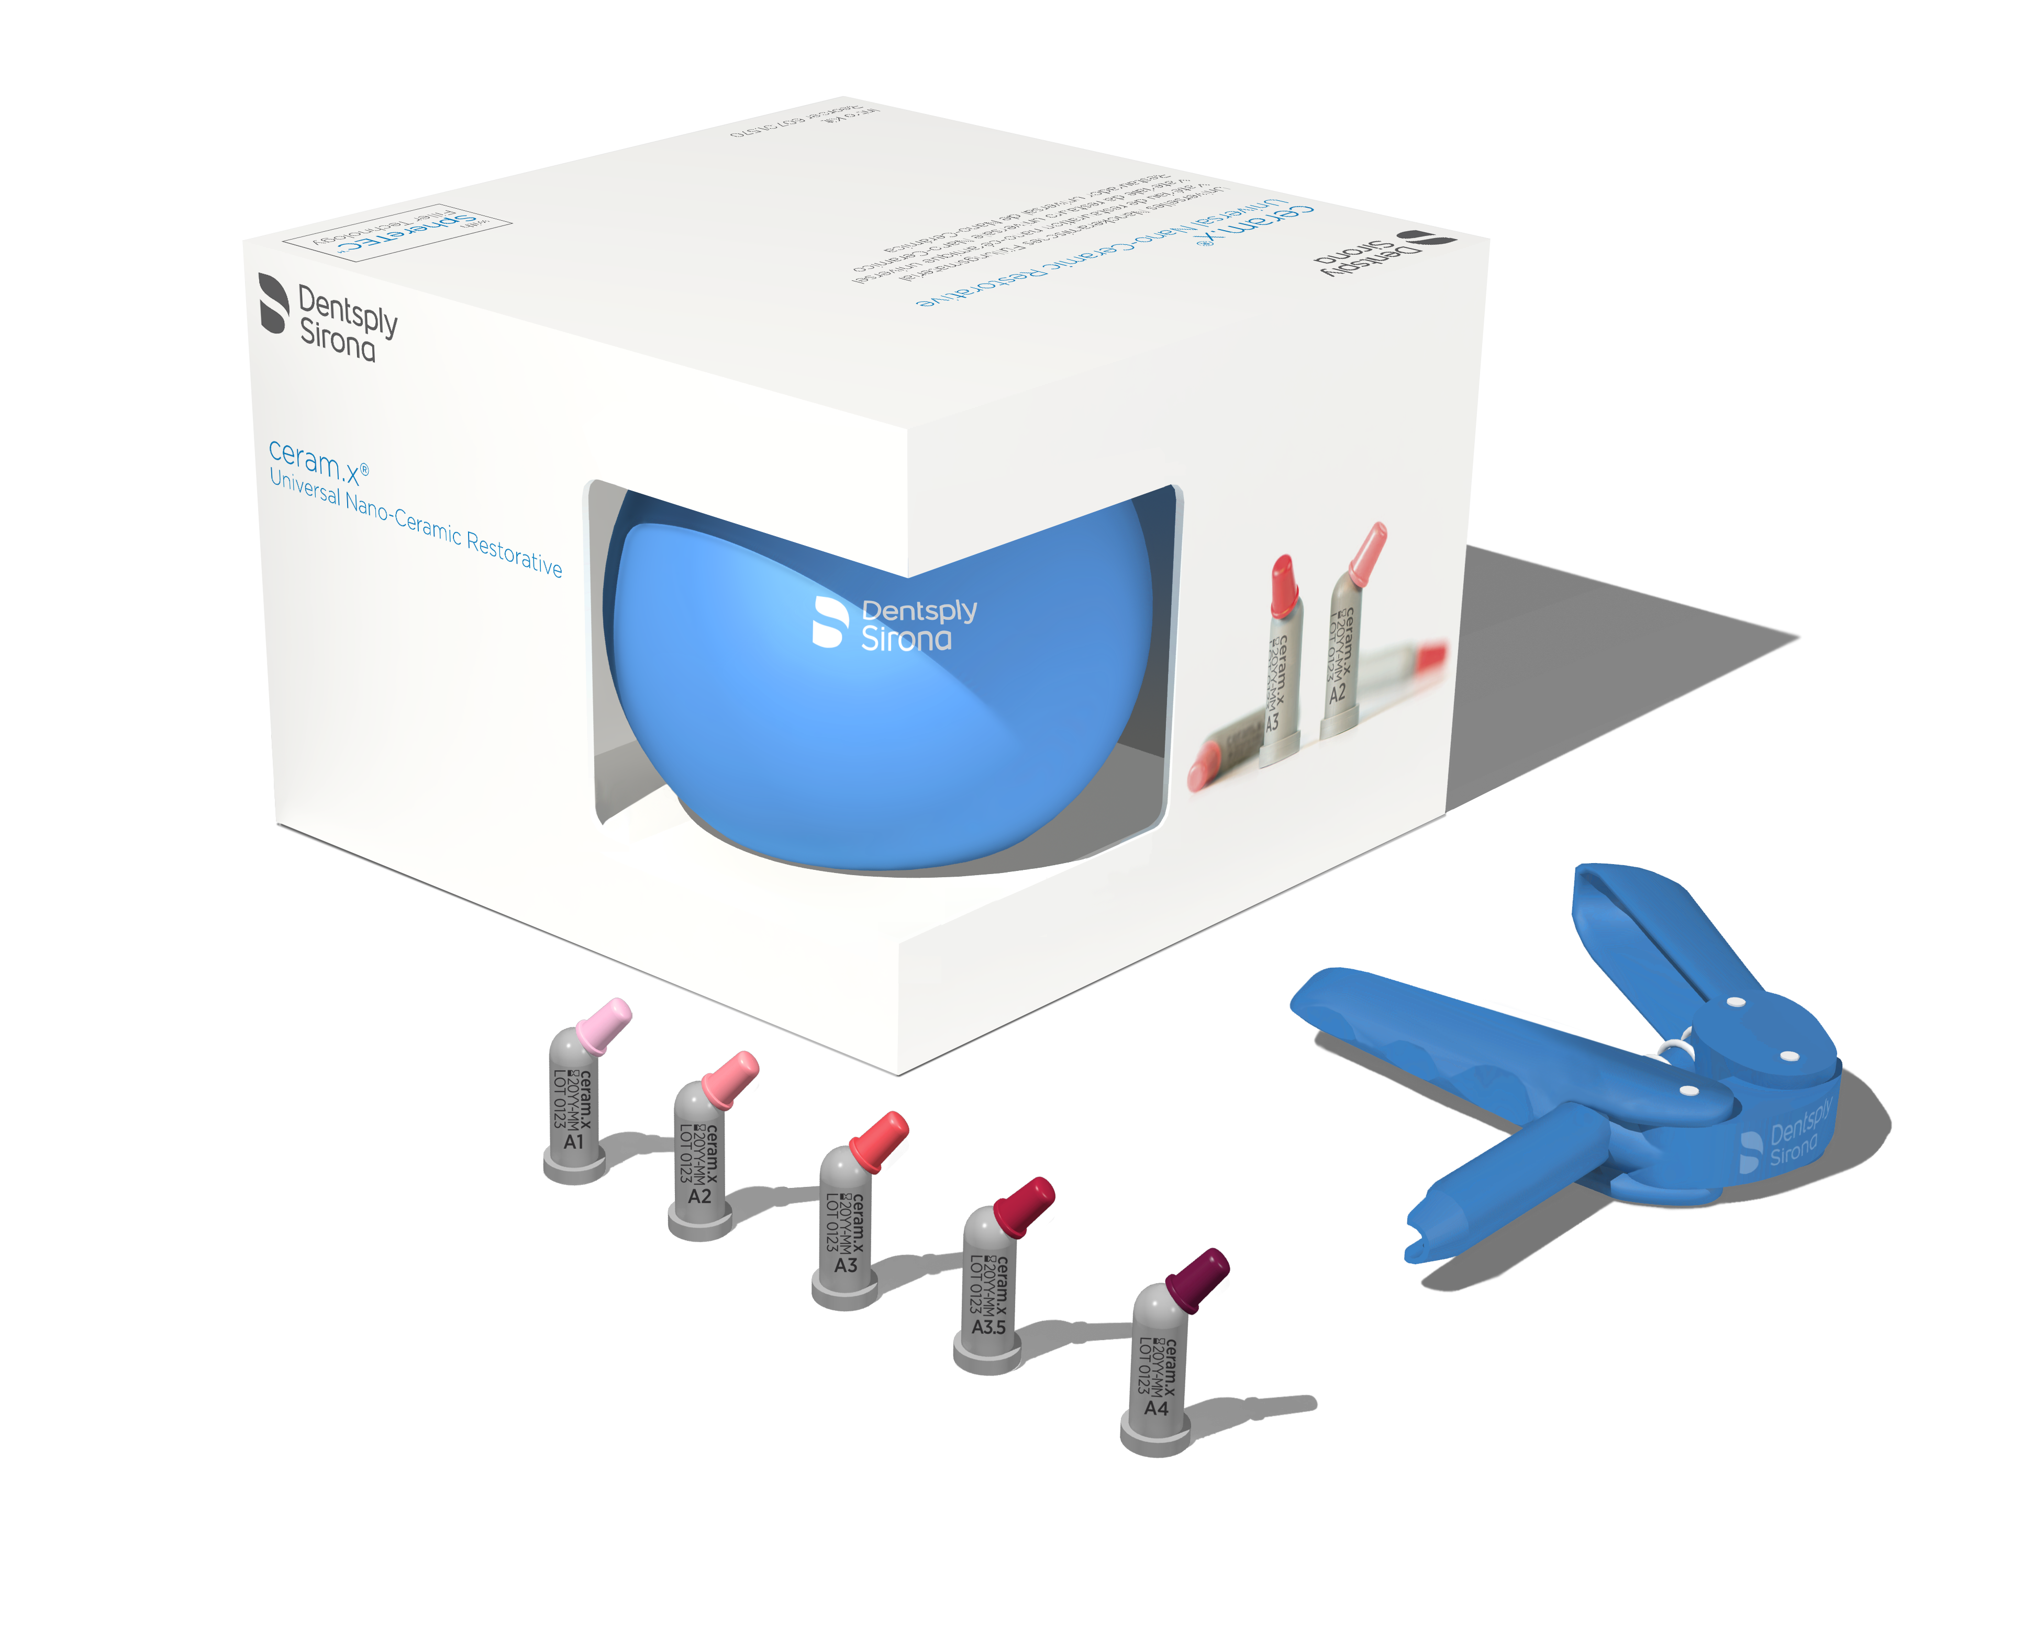

The evaluators rated the ease of use of their current resin composite material as follows:

Difficult 1 5 Easy 4.3

The overall presentation of the kit was rated as:
Poor 1 5 Excellent 3.6

The evaluators rated the illustrated technique guide/instructions for ceram.X
as follows:
Poor 1 5 Excellent 4.8

One hundred and forty-five restorations were placed using ceram.X Universal, with 66% being Class II/MOD. All (100%) the evaluators stated they were satisfied with ceram.X, with only one evaluator encountering post-operative sensitivity (which settled after one week).
The ease of use of ceram.X was rated by the evaluators as follows:
Difficult 1 5 Easy 4.8

The viscosity of ceram.X was stated to be satisfactory by all 100% of the
evaluators
The evaluators rated the working time of ceram.X as follows:
Too short 1 5 Too long 3.0

The ease of finishing and polishing of ceram.X was rated as follows:
Difficult 1 5 Easy 4.4

75% (n=9) of the evaluators stated that the number of shades were adequate. Comments made included:
“Please add B & D opaque shades (2 similar).
All the evaluators stated that after sculpting the restorations of ceram.X Universal maintained their shape prior to curing. Eleven (92%) of the evaluators stated that they would purchase ceram.X Universal if it were available at an average price, and all would recommend it to colleagues. Final comments regarding the performance/handling and overall acceptability of ceram-X included:
“Excellent handling properties. Venus tends to be stiffer. ceram.X
easier to manipulate but shades a little more translucent so opaque shades
would be good”
“Material has user-friendly consistency & unique shade system works well”
“Not sticking to instruments made moulding and sculpting much easier”
“Excellent Universal composite. Excellent handling & polish”
“Wide tip loaded material nicely into large cavities so avoiding voids
and great to sculpt to a smooth finish”
“Excellent to adapt to tooth and to shape. Great consistency”
“Compares well with other brands in handling. Shades and application”
“Would be useful to have value order of the shades to compare with
Vita shades”

Dentsply Sirona Enhance finishing system.
Figure 4: The Dentsply Sirona Enhance finishing system, including Prisma Gloss, an aluminium oxide polishing paste

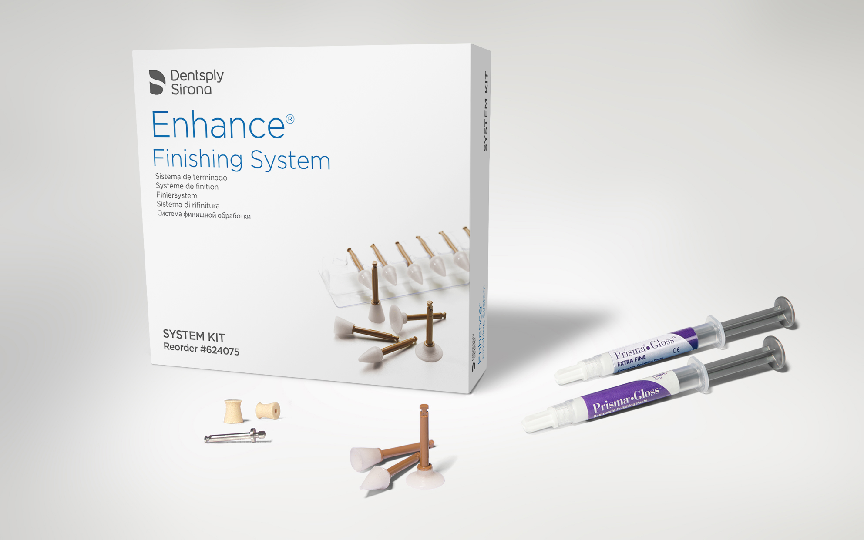

The presentation of the Enhance Finishing system kit was rated by the
evaluators as follows:
Poor 1 5 Excellent
4.8
Comments:
The evaluators rated the instructions for the kit as follows:
Poor 1 5 Excellent
5.0

A total of 200 composite restorations were polished using Enhance, comprising 37% of anterior restorations and 63% of restorations in posterior teeth.
The evaluators and their dental nurses rated the overall performance of the
Enhance system as follows:
Inconvenient 1 5 Convenient 4.8
Comments:
All the evaluators stated the Enhance finishing, discs, cups and points were
suitable for both anterior and posterior restorations.
When the evaluators were asked which finisher they used most frequently the response was as follows:
Most frequently: Discs:4 Cups:1 Points:6 All three equally:3
Least frequently: Discs:2 Cups:7 Points: 1

67% (n= 8) of the evaluators stated the polishing cups were satisfactory.
Comments relating to the cups:
“A little cumbersome to put together”
“Poorest part of the system – firm with little flexibility”
“Didn’t like them as much as the discs”
“Used before and find them excellent”
Comments made on the Prisma Gloss and Prisma Gloss Extra Fine pastes
were as follows:
“Best polishing paste available”
“Easy to use and nice consistency”
“Produced good lustre on final polishing” (3 similar)
“In combination with ceram.X the Enhance polishers and pastes
achieved an excellent surface”
When the evaluators were asked if the finish on the restorations was
satisfactory, the response was as follows:
No 1 5 Yes 4.5

The response when the evaluators were asked to describe how Enhance
compared to the polishing system previously used, the result was as follows:
Better 5 evaluators
Same 5 evaluators
Worse 1 evaluator
No response 1 evaluator

The time needed to achieve polish was stated to be:
Better 3 evaluators
Same 7 evaluators
Worse 1 evaluator
No response 1 evaluator
The evaluators stated that on average the same polishing instrument was
used twice before it needed to be replaced.
The product features of the new polishing system that most satisfied the
evaluators were stated to be:
“Speed to produce a good finish”
“No mandrel needed, and consistent finish” (2 similar)
“Good shapes and kit presentation”
“Easy to use (n=3), well presented and good polish”
“As a present user, I get good results but for restorations in the
aesthetic zone I use polishing discs as well on occasion”

The evaluators rated the overall ease of use of the Enhance system as follows:
Difficult 1 5 Easy
4.6

83% (n=10) of the evaluators would recommend the Dentsply Sirona Enhance
finishing system to colleagues.
Final comments:
”A great accompaniment to the Dentsply Sirona delivery systems”
“Easy to use and reliable results”
“I found it could over-polish at the margin creating a ledge”
“I have used the Enhance points for many years but the study re-
introduced me to Prisma Gloss that I have since used for many restorations”

DISCUSSION
Prime & Bond Active
The Dentsply Sirona Prime and Bond Active adhesive system is one of the new group of “Universal” dentine bonding systems, so called because they have been designed to work satisfactorily in whichever etching mode (self-etch [i.e no etchant], total etch [i.e. both enamel and dentine etched with phosphoric acid], or selective enamel etch [in which only the enamel is etched])⁸. In common with other recently introduced “Universal” dentine bonding systems, the bonding agent contains the resin 10-MDP (Table 1), alongside the resin PENTA which has been a component of Dentsply’s bonding systems for many years. The inclusion of 10-MDP, which was developed in the 1980s, may be considered to be advantageous in bonding to tooth substance because it forms a chemical bond ionically to calcium, i.e. to hydroxyapatite in dentine, whereas bonding agents (without 10-MDP) had previously only achieved their bonding by micromechanical means involving the formation of the “hybrid layer”⁹.
Table 1: The components of Prime and Bond Active
10-MDP
PENTA
Initiator
Isopropanol
Water

Prime and Bond Active bonding agent has been subjected to an extensive evaluation in clinical practice in the present study, in which 414 restorations were placed by members of the PREP panel. The presentation of the material scored very highly (4.9) on visual analogue scales where 5 = excellent and 1 = poor). Prime and Bond Active achieved the same high rating by the evaluators for ease of use as the previously used adhesive system, (4.8 on a visual analogue scale where 5 = easy to use and 1 = difficult to use).
Palodent V3
The achievement of a tight, correctly-placed interproximal contact (Figure 5) has exercised clinicians for many years, since matrix systems, such as the Siqveland which work satisfactorily for amalgam restorations, have not been shown to be suitable for resin composite class II and MOD restorations. The introduction of sectional matrix systems has facilitated the achievement of satisfactory interproximal contacts, as evidenced by a study from The Netherlands¹⁰.
Figure 5 Interproximal contact points: 1 is the ideal, the contact points in 2, 3, and 4 are defective in different ways

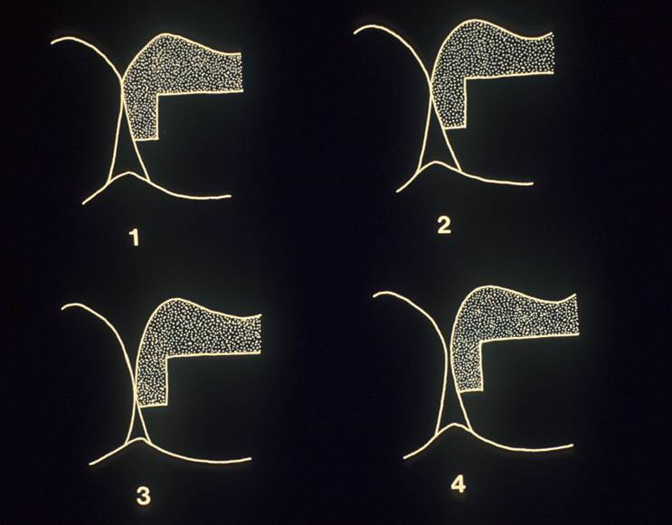

In this regard, The Palodent V3 Sectional Matrix System has been subjected to an extensive evaluation in clinical practice by members of the PREP panel. Eleven evaluators (92%) reported no patient complaints of interproximal food packing following use of the system, indicating that the matrices had achieved their objective, namely, a firm anatomically correct contact point on most occasions. The system achieved a similarly high rating by the evaluators for ease of use as their previously used sectional matrix system, (4.2 v 4.3 on a visual analogue scale where 5 = easy to use and 1 = difficult to use), but this may be considered unsurprising, given that five evaluators already used the system. It is of interest to note that some evaluators did not appear to be limited by the interproximal box width when using the system, with 7 using it for a “wide box” and 5 for cusp replacements, which previously might have been considered to be the territory for a circumferential system.
Figures 6 and 7 demonstrate the satisfactory interproximal contacts which may be achieved.
Figure 6
UR4 Class II DO: Prime and Bond Active, Palodent v3, SDR Flow+ & ceram.X Universal

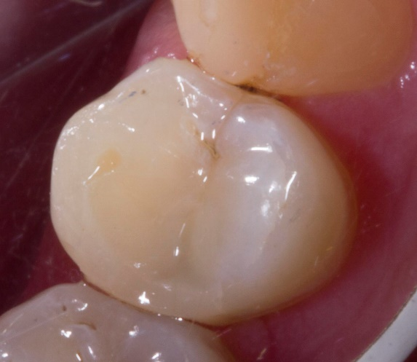

Figure 7 a, b, and c.
LL5 Class II DO : Prime and Bond Active, Palodent v3, SDR Flow+, ceram.X Universal
- Matrix and ring placement, with selective enamel etch.
- Placement of initial increment of composite
- Completed restoration.
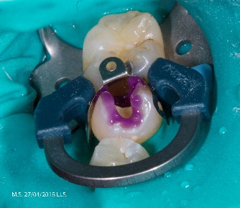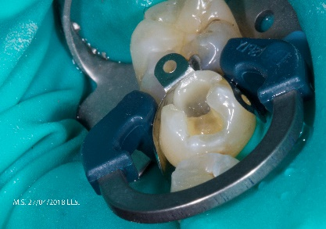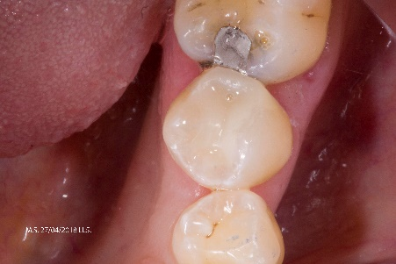

Dentsply Sirona SDR Flow +
The original Dentsply SDR was designed as a low shrinkage stress material for bulk filling restorations in posterior composite at depths of up to 4mm, followed by placement of a resin composite outer layer. Dentsply Sirona SDR Flow + is, similarly, a low stress material. It has been subjected to an extensive evaluation in clinical practice by members of the PREP panel, in which 127 restorations were placed. It scored highly in all of the attributes which were rated, but principally on its ‘simplicity of procedure’ and ‘internal cavity adaptation’. In addition, when the comments of the evaluators are examined, it is apparent that at least half considered that the use of SDR Flow + saved time during the placement of a posterior composite restoration.

Ceram-X Universal
Dentsply Sirona ceram.X Universal has been subjected to an extensive evaluation in clinical practice by members of the PREP panel, in which 145 restorations were placed. The presentation of the system score (3.6 on a visual analogue scale where 5 = excellent and 1 = poor), was the only aspect of the evaluation which scored suboptimally, given that ceram-X Universal otherwise featured exceptional high scores for the material. Comment was made by over half the evaluators of the impractical nature of the packaging: the authors are, however, advised that the evaluators were provided with a promotional pack, and not the packaging that is in current use. This aside, the material scored very highly, including bettering the score for ease of us of the previously used resin composite material (4.8 v 4.3 on a visual analogue scale where 5 = easy to use and 1 = difficult to use) and with all the evaluators stating they would recommend the material to colleagues, and also that 92% would purchase the material.
Enhance
Dentsply Sirona Enhance finishing system has been the subject of an extensive evaluation in clinical practice by members of the PREP panel, in which 200 restorations were polished. The Enhance finishing system scored very highly to for ease of use (4.6 on a visual analogue scale where 5 = easy to use and 1 = difficult to use) and 83% of the evaluators stated they would recommend the material to colleagues. In this regard, it is interesting to note the findings of a paper by Daud and colleagues¹¹, who, in a laboratory study, examined the surface roughness of resin composite specimens polished using different systems. Their results indicated that the Enhance polishing system produced a significantly smoother surfaces than the Soflex (3M) system. Also, perhaps of interest is the fact that finishing with a tungsten carbide finishing bur produced significantly less surface irregularity than finishing with a 20micron diamond finishing bur and that the nanofilled composite under test produced baseline specimens than the hybrid composite.
CONCLUSIONS
- The good reception of Prime and Bond Active was underlined by the fact that the majority of the evaluators would purchase the material if available at average cost and the very high score for ‘ease of use’.
- The good scores achieved by the Palodent V3 Sectional Matrix System are underlined by the doubling of numbers of evaluators from the 5 original users of the system, to 10 who would recommend the system to colleagues.
- The positive reception of Dentsply Sirona SDR Flow + is underlined by the 92% of evaluators who were satisfied with the material and who would also recommend it to colleagues.
- The positive reception of Dentsply Sirona ceram.X is underlined by the 92% of evaluators who would purchase the material and the 92% who would also recommend it to colleagues.
- The Dentsply Sirona Enhance finishing system has been well received and overall achieved high scores with 83% of the evaluators stating they would recommend it to colleagues.
Final, unsolicited comments from the evaluators included:
“Prefer to mix and match”,
“Composite placement is personal and I don’t believe ‘one size fits all’ in relation to materials”,
“Good concept with a ‘one-stop’ kit & a good starting point”.
Six evaluators (50%) considered that the kit made the average cost of placing a direct composite clearer, to the benefit of their business, making comments such as:
“Easier to calculate restoration cost”,
“Complete kit streamlines the costing of materials” and,
“It would be helpful if told the average number of restorations per kit”.

Concluding comments
This is the first instance in which, to the authors’ knowledge, all the components required for placement of a class II resin composite restoration have been brought together in one complete kit. The individual components performed well in this “handling” evaluation, but the concept of having all components in one kit appeared to appeal to many of the evaluators, especially with regard to calculating the material cost of a given restoration if the manufacturers could suggest the number of restorations that the kit might produce.

Finally, figure 8 presents a preventive resin restoration placed using the components of the system (except for the matrix system), and Figure 9 presents a restoration placed using all the components the Dentsply Sirona Class II Solutions system. All restorations illustrated in this paper were placed by Dr Peter Sands, General Dental Practitioner, Abingdon, UK.

Figure 8
LL6 & 7 Class I’s SDR Flow+, ceram.X & sealant

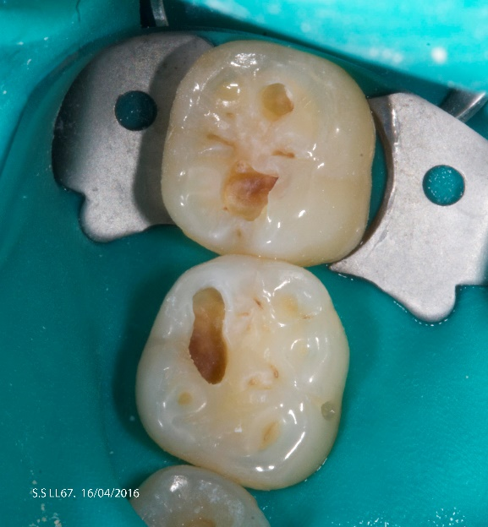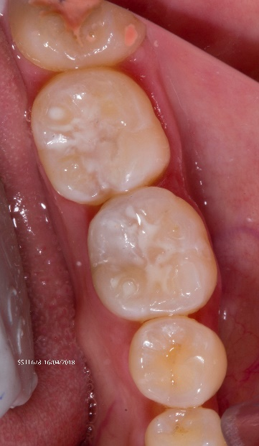

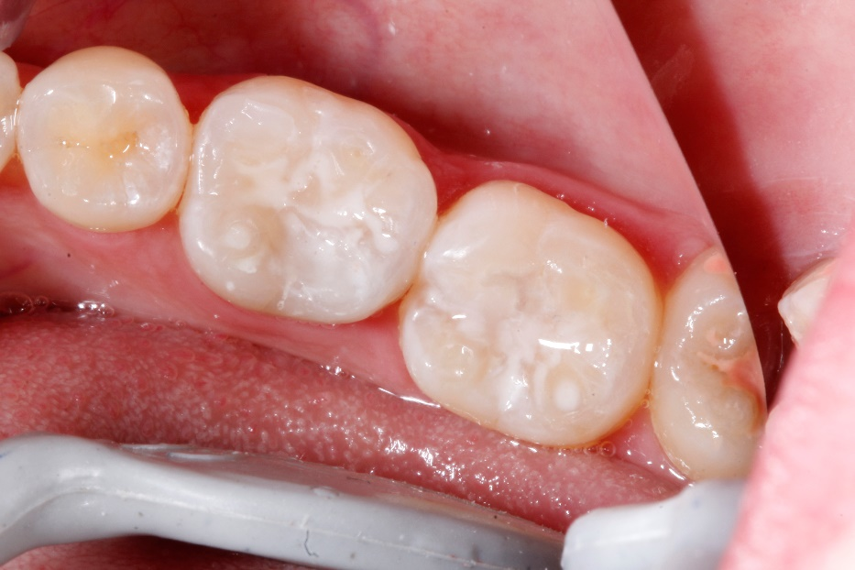

Figure 9
LL5 Class II DO, Palodent V3, SDR Flow+, ceram.X Universal
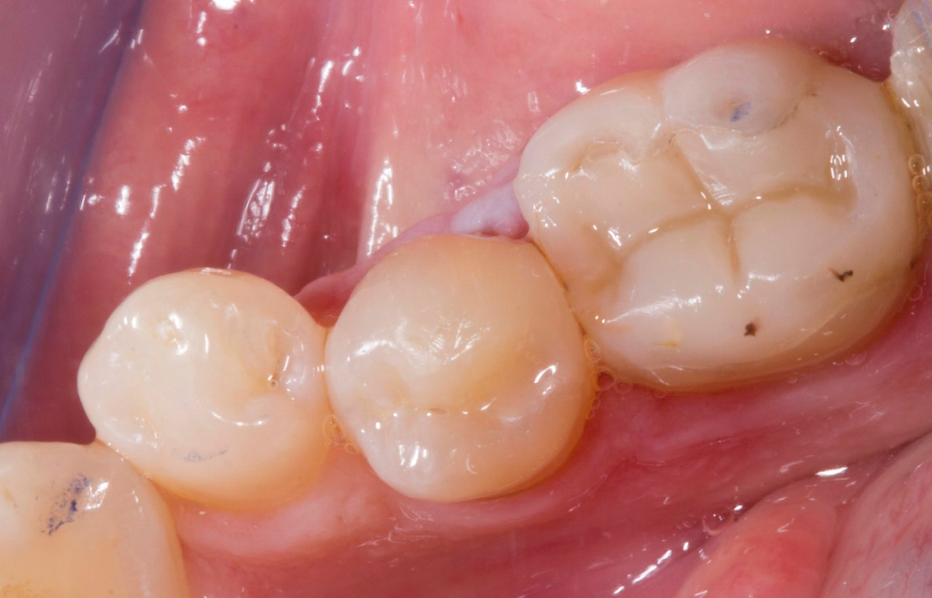

MANUFACTURER’S COMMENTS
Dentsply Sirona would like to thank the members of the PREP Panel in evaluating and sharing the feedback around our recently introduced Class II Solutions system. We are pleased with the responses received and believe that the findings of the study support our commitment to delivering better, safer, faster dentistry to clinicians. It is also worth pointing out, given the positive reception for ceram.X Universal, that on December 1st, 2018, ceram.x universal composite will be re-branded to Ceram.x Spectra™ ST composite – High Viscosity (HV). Each product in the Ceram.x Spectra™ ST Composite portfolio will continue to utilize Dentsply Sirona’s novel SphereTEC filler technology to deliver optimized performance in the areas that matter most to dentists.

ACKNOWLEDGMENTS
The authors thank the members of the PREP Panel for completing the feedback forms and thank Dentsply for providing the material and funding this evaluation.

CONFLICT OF INTEREST
The authors do not have any financial interest in the company whose material was included in this study.
REFERENCES
1.Burke FJT, McCord JF. Research in dental practice – problems and solutions. Br.Dent.J.1993:175:396-398.
2. Burke FJT, Crisp RJ. Twenty years of handling evaluations and practice-based research by the PREP Panel. Dent.Update. 2013:40:339-341.
3. Burke F.J.T. Amalgam to tooth-coloured materials – implications for clinical practice and dental education: governmental restrictions and amalgam-usage survey results. J.Dent.2004:32:343-350.
4. Pallesen U, van Dijken JW, Halken J, Hallonsten A-L, Höigaard R. Longevity of posterior resin composite restorations in permanent teeth in Public Dental Health Service: a prospective 8 years follow up. J.Dent. 2013;41:297-306.
5.Opdam N, van de Sande F, Bronkhorst E, Cenci M, Bottenberg P, Pallesen U. Longevity of Posterior Composite Restorations A Systematic Review and Meta-analysis. J.Dent.Res. 2014;93:943-949.
6. Astvaldsdottir A, Daerhamn J, van Dijken JWV, Naimi-Akbar A, Sandborgh-
Englund G, Tranieus S, Nilsson M. Longevity of posterior resin composite
restorations in adults -a systematic review. J.Dent.2015:43:934-954.
7. Opdam NJM, Bronkhorst EM, Loomans BAC, Huysmans M-CDNJM. 12 year survival of composite vs amalgam restorations. J.Dent.Res.2010:89:1063-1067.
8.Burke FJT, Lawson A, Green DJB, MacKenzie L. What’s new in dentine bonding? Universal adhesives. Dent.Update.2017:44:328-340.
9. Van Landuyt KL, Yoshida Y, Hirata I, Snauwaert J, De Munck J, Okazaki M, Suzuki K, Lambrehts P, Van Meerbeck B. Influence of the chemical structure of functional monomers on their adhesive performance. J.Dent.Res.2008:87:757-761.
10. A randomised clinical trial on proximal contacts of posterior composites
Loomans BAC, Optam NJM, Roeters FJM. J.Dent.2006:34:292-297.
11. Daud A, Gray G, Lynch CD, Wilson NHF, Blum IR. A randomised controlled study on the use of finishing and polishing systems on different resin composites using 3D contact optical profilometry and scanning electron microscopy. J.Dent.2018:71:25-30.

